Flam Assignment
Research And Development

Name: Giridhar (CH.EN.U4CSE22020)
Domain: R & D

1.What is a Parametric Equation ???
- When independent variables forms a curve or surface (Parametric Equation)
- Independent Variable = parameters
- Each variable has its own function.
Eg:
X=f(k) Y=g(k)

2.From the Given Question:
Problem:
Find the values of unknown variables in the given parametric equation of a curve :

$$x = \left( t*\cos\left(θ\right)- e^{M*abs\left(t\right)}*\sin\left(0.3*t\right)*\sin\left(θ\right)+ X \right)$$

$y = \left(42 + t*\sin\left(θ\right)+ e^{M*abs\left(t\right)}*\sin\left(0.3*t\right)*\cos\left(θ\right)\right)$

Given range for unknown params is

$$0^{∘}< θ< {50}^{∘},$$
$$-0.05 < M < 0.05,$$
$$0 < X < 100$$

parameter ‘t’ has range:
6<t<60

Unknowns :
$θ$ ,M,X

Objective : To check the predicted curve match the given points

Approach:

1.Intially Understand how the curve of the graph will look like for the given X and Y Parameters
2.Understanding and mapping the data to parameter t from the given problem

3. From the given xy_data.csv file there are 1500 points which each row has it corresponding steps
tᵢ = 6 + (1499 × i) / (60 − 6), for i = 0, 1, …, 1499

3.Computing predicted x,y coordinates
Substitute different values to the parameters $θ$ ,M,X

  - Convert to radians(because trigonometric functions use radians )
θ_rad = θ × (π / 180)
θ (angle in degrees) and θ_rad(angle in radians)

3.2 Exponential term : e_i = exp(M * |t_i|)

  - Predicted x coordinate:

x_pred,i = t_i * cos(θ_rad) - e_i * sin(0.3 * t_i) * sin(θ_rad) + X

  - Predicted y coordinate:
y_pred,i = 42 + t_i * sin(θ_rad) + e_i * sin(0.3 * t_i) * cos(θ_rad)

4.Measuring the Distance :
4.1 To measure the L1 Distance (also known as Manhattan Distance ). This measures how far two points are by adding up the absolute difference between x and y coordinates
4.2 This method helps us to find the distance by moving along grid like paths (like moving in different paths instead of straight line from source to destination)

Eq 4 E(θ, M, X) = Σ (|x_pred,i - x_i| + |y_pred,i - y_i|) for i = 0 to 1499

5.Estimation
Estimating θ (the angle)
Estimating X (horizontal shift)
Estimating M (exponential growth or decay)

- After performing we guess the value of θ,X,M and apply these values in the L1 error formula (Eq 4)
- Testing how the error changes when parameter are adjusted slightly
- Using 5-6 subset points to calculate the L1 error
- The above parameters are iteratively changed and adjusted and recalculating the L1 error

Target output: continue the process to get the smallest error so we get the E(θ, M, X) values

Output sample screenshots:
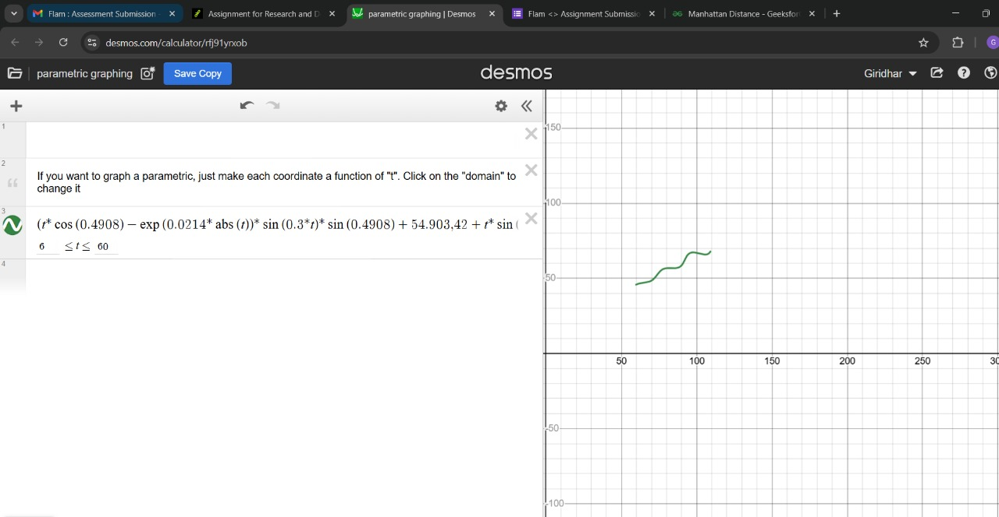

Fig 1: Desmos graph
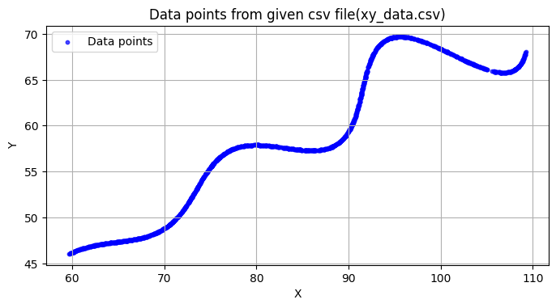

Fig 2: Data points of (xy_data.csv)

References :
Lamar University. (n.d.). Parametric equations. In Paul’s Online Math Notes. Retrieved from https://tutorial.math.lamar.edu/classes/calcii/parametriceqn.aspx
GeeksforGeeks. (n.d.). Manhattan distance. Retrieved from https://www.geeksforgeeks.org/data-science/manhattan-distance/

